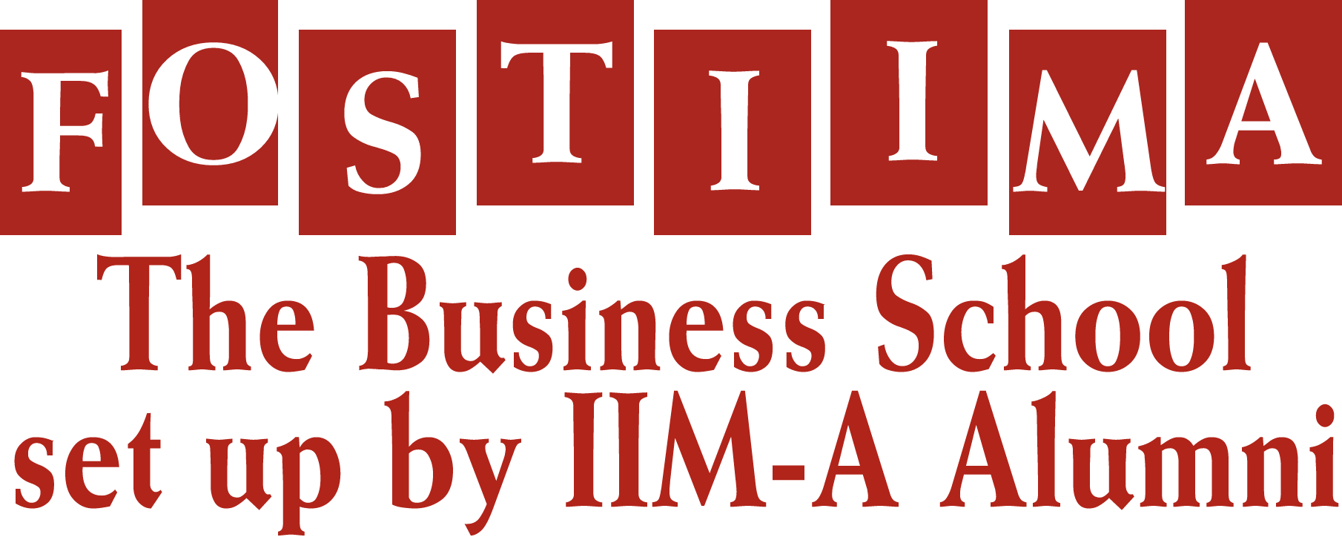

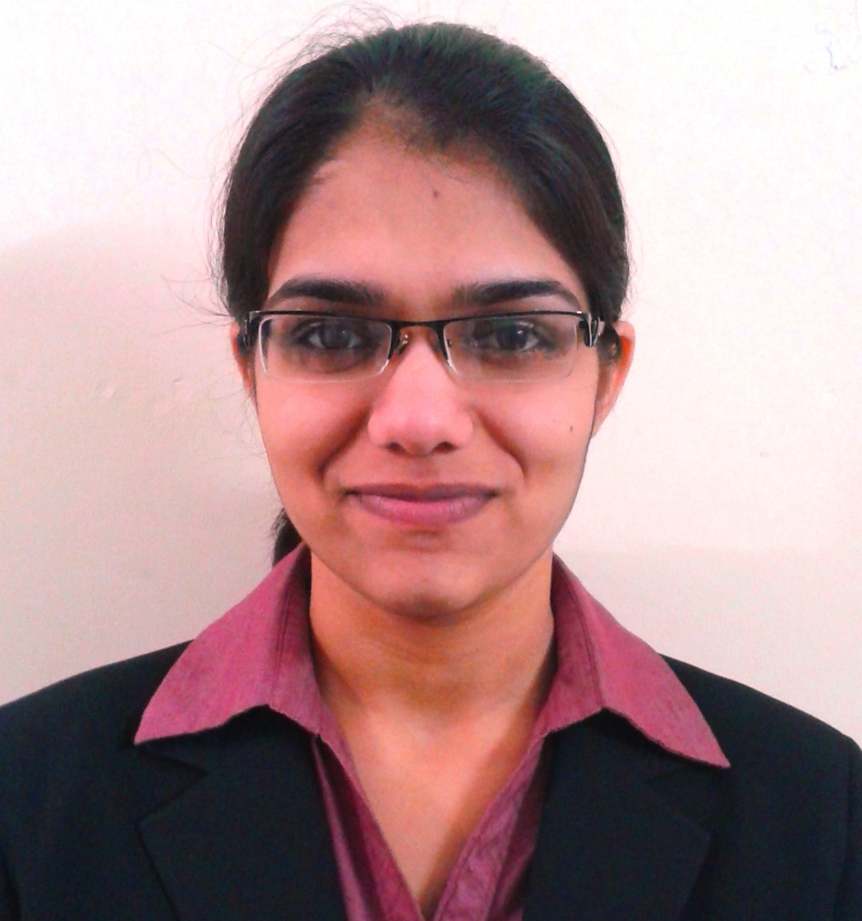

**YASHANKITA**

**Gender:** Female, **Age:** 21 years, **Mobile:** 9871315994

**E-mail Id:** yashankita@fostiima.org,

**INTERNSHIP Duration: 2 Months**

**Company Name**: Caparo Maruti Ltd. **Department**: HR, Admin & Sales Udyog Vihar, Gurgaon

**About Caparo Maruti Limited (CML**): It’s a world-class tier 1 sheet metal stamping, weld assemblies & closures supplier to Maruti Suzuki (India) & General Motors (India)

**Key Responsibility Area:**

* Creating database of candidates registering through companies Job Portal
* Calling the candidates and lining them up for the Interview
* Handling office management, such as maintaining muster roll etc.
* Planning and organizing entertainment & fun activities such as carom, chess etc on weekly basis
* Planning and Coordinating reward and recognition events for the employees
* Learnt training and development process
* Worked on the salary process of the employees with its various components such as PF Calculation, ESI Calculation etc

**Summer Internship Project:**

**#** Six Sigma in Recruitments

**ACADEMIC CREDENTIALS**

|  |  |  |  |
| --- | --- | --- | --- |
| **Class / Course** | **Year** | **School / College** | **CGPA/Marks** |
| MBA/PGPM | 2012-2014 | FOSTIIMA Business School, New Delhi | 5.48/10 |
| BA | 2012 | Fateh Chand College, Hisar | 58% |
| XII | 2009 | St Nischal Sr Sec School, Hisar | 63% |
| X | 2007 | ID DAV Public School, Hisar | 61% |

**ACADEMIC PROJECTS**

* **Project title**: **Coca Cola** (Marketing)

**Targeted areas in the project:**

* Targeting and positioning rural market of India
* Reviewing the journey from urban areas to rural areas
* Three A’s marketing strategy was used:
  1. Availability
  2. Affordability
  3. Acceptability
* How Advertising strategy was used to enhance the sales
* **Project title: LAZEEZ,** aParantha Restaurant of its own kind (Market Research)

**Targeted areas in the project:**

* + Analysing the strategies of various Parantha joints in South Delhi
  + Preparing a questionnaire to understand the psyche of the customers when it comes to their eating habits
  + Understanding the pricing strategies and preparing the rate chart for Paranthas
  + Preparing the financial plan to understand the cost to set up a restaurant
* **Project title: HRIS** (Human Resource Management)

**Worked on HRIS:**

* Record keeping requirement
* HR Diagnosis process

**Development:**

* SDLC
* People checklist

**ACHIEVEMENTS AND AWARDS**

* Bagged 1st prize in Slogan writing competition at graduation level
* Runner up in badminton championship at FOSTIIMA
* Part of the Organizing Committee for the event “Walk for Life” for Can support - A NGO in aid of cancer patients in New Delhi
* Awarded in school for 100% attendance
* Member of News Room Club at FOSTIIMA Business School

**SKILLS AND INTERESTS**

* Interest in calligraphy & have been awarded for best handwriting in the class
* Ability to deliver under pressure and at short notice
* Punctual, Focused and Flexible
* Proficient with MS Office
* Interested in sports & love to play badminton
* Teaching students in leisure time